**BHAKTAPUR MULTIPLE CAMPUS**

**AFFIIATED TO TRIBHUVAN UNIVERSITY**

**DUDHPATI-16, BHAKTAPUR**

**A FINAL YEAR REPORT PROJECT REPORT ON**

**COFFEE SHOP MANAGEMENT**

**Under the supervision of**

**Mr. Sushant Poudel**

**Coordinator**

**Submitted by**

**Subheksha Adhikari (Roll No.71)**

**Submitted to**

**Mr.Sushant Poudel**

**Bhaktapur Multiple Campus**

**Date-2075/02/12**

**ACKNOWLEDGEMENT**

I am glad to take this opportunity to express my sincere gratitude to supervisor of this report Mr. Sushant Poudel (coordinator) for his guidance, support and valuable suggestions and coordination on making this report. It was indeed a great learning experience.

I am also grateful to my other teachers, seniors, elders, and my friends for their direct or indirect support, and valuable suggestions.

Finally, I would also like to take this opportunity to acknowledge the contribution of all those who have published their reports and articles in related field in various media for the benefit of student like me.

**ABSTRACT**

The project titled as "Coffee shop management system" is developed with the main aim is to make a complete solution for coffee sales system. This project has login module, coffee details module, coffee sales module, billing module, coffee purchase module and reports module.

The administrator should enter the username and password to enter into the project. If the username and password are mistake, it will say error message. If it is correct it will show next form. All coffee details are entered in this module. The coffee name, coffee flavour, coffee price and the stock of coffee available are entered in this module. The coffee details can be modified or deleted if the coffee is not available in the shop. The coffee provider’s details are entered in this module like name, address and contact numbers are entered in this module. The entered dealer/provider details can be modified or deleted by the administrator. The coffee sales details are entered in this module. The coffee is selected from the list of coffee available. The coffee flavour and coffee price is selected from the database and displayed in the form. The number of coffee is entered in this form and the total price for the coffee are calculated and displayed. . The coffee purchase details are entered in this module. The coffee is selected from the list of coffee available. The coffee flavour and coffee price is selected from the database and displayed in the form. The number of coffee is entered in this form and the total price for the pet are calculated and displayed.

The purchase will increase the stock of the particular coffee in the shop. All coffee reports, coffee stock reports and the sales reports are displayed to the administrator through this module.

**TABLE OF CONTENTS**

UNIT PAGE NO.

Introduction………………………………………………………………………………………………………………….....1

Objectives………………………………………………………………………………………………………………………….2

System Analysis………….………………………………………………………………………………………………....3

System Design……....………………………………………….……………………………………………………….……4

Data Flow Diagram…….…………………….……….………………………………………………………………….4

ER Diagram……………...………………………………………………………………………………………….……………5

User Case Diagram…………………………………………………………………………………….…………………...6

System Testing……..……………….………………………………………………………………………………………7-8

Requirements…….…….………….……………………………………………………………………………………………9

Results…….…………………………………………………………………………………………………………………………10

Conclusion……….……………………………………………………………………………………………………………….11

Reference……………..…..……………………………………………………….………………………………………………11

**INTRODUCTION**

In today’s world, age of modern science and technologies, everything we do are directly or indirectly based on the use of various inventions and utilities of computer science.Every types of management systems are meaningful and convenient because of them.

The topic chosen”Coffee Management System” is a simple yet really important example for the applications of the Computer science and Information technology in that particular field. “Coffee Shop” has been a really scoped and beneficial and more convenient business activity carried out by people from small to a very large scale basis.

It is about using computer technology for managing the shop and getting benefits at its maximum extent. Unlike the topic, this is not only applicable for just that particular coffee shop business but also many others that relatable. This kind of management saves time. Money and effort of the businessman .So, in the Dymanic and modern era we are living today, it is admittable that without such modern systems, no upgrading is possible.

**OBJECTIVES**

1. To provide user friendly environment, where a normal user can easily access through all the benefits of the system.
2. To provide security from unauthorized access, only admin or authorized users are access-granted to the system.
3. To increase efficiency and also save time.

**SYSTEM ANALYSIS**

The process of studying an activity (as a procedure, a business, or a physiological function) in order to define its goals or purposes and to discover operations and procedures for accomplishing them most efficiently .Analysis is defined as the procedure by which we break down an intellectual or substantial whole into parts. Synthesis is defined as the procedure by which we combine separate elements or components in order to form a coherent whole. Systems analysis researchers apply methodology to the analysis of systems involved to form an overall picture. System analysis is used in every field where there is a work of developing something. Analysis can also be defined as a series of components that perform organic function together.

It also comprises the feasibiliy Study:

1. Technical feasibility
2. Econnomic feasibility
3. Legal fesibility
4. Operational feasibility

**SYSTEM DESIGN**

The overall system developed as Coffee shop management is a modular, themeable, lightweight with popular modern management strategy. It is designed to be simple enough for any developer to create modules and for any end user to understand how it works.

The work of defining the data flow in the system plays a major role in the performance and the robustness of the system. The overall data flow in the system is designed and represented through various diagrams.

**DATAFLOW DIAGRAM**

The data flow diagram (DFD) is a tool for drawing a model or picture of a system. It illustrates the flow of data and work through the system.

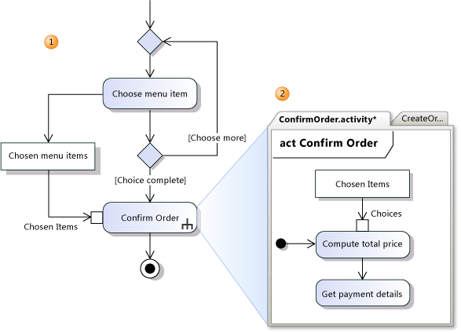

Fig: Dataflow Diagram showing Coffee shop management System

**ER DIAGRAM**

An Entity Relationship Diagram is a snapshot structures. ERDs show entities in a database and relationships between tables within that database. It is essential to have one of these if you want to create a good database design. The patterns help focus on how the database actually works with all of the interactions and data flows.

Having gained some understanding of foreign keys and referential integrity in the previous section it is now possible to complete the coffee shop database with the appropriate ER diagram.

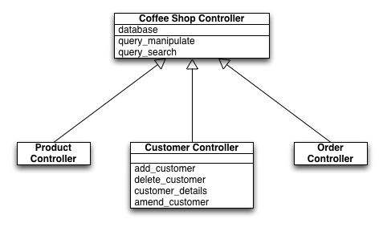

Fig: ER Diagram for Coffee Shop Management System

**USE CASE DIAGRAM**

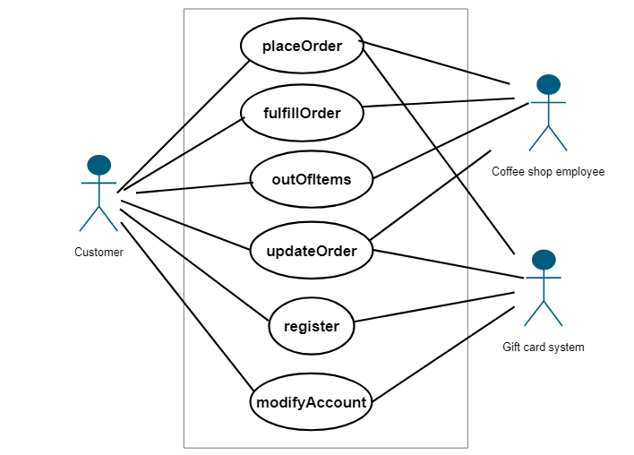Use Case Diagrams describe what a system does from the viewpoint of an external observer. The emphasis is on what a system does rather than how. Use Case Diagrams are closely connected to scenarios. A scenario is an example of what happens when someone interacts with the system.

Fig: Use Case Diagram

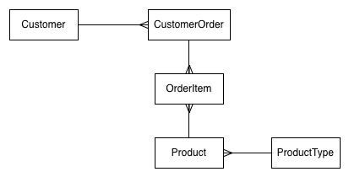**BRIEF DESCRIPTION**

Customer (Customer, FirstName, LastName, Street, Town, PostCode, TelephoneNumber, EmailAddress)

CustomerOrder (OrderID, Date, Time, *CustomerID*)

OrderItem (OrderItemID, *OrderID*, *ProductID*, Quantity)

Product (ProductID, Name, Price, *ProductTypeID*)

ProductType (ProductTypeID, Description)

**SYSTEM TESTING**

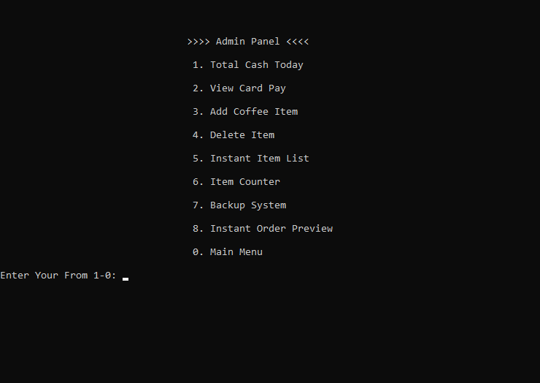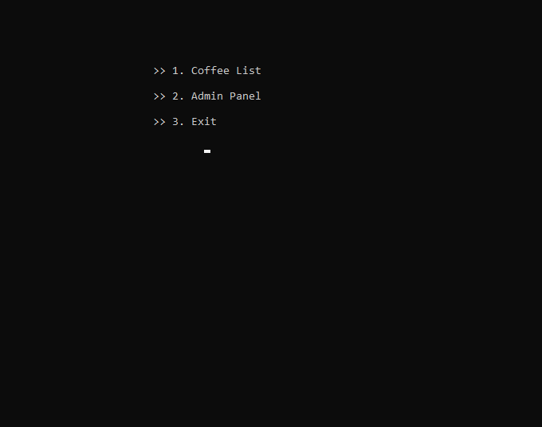

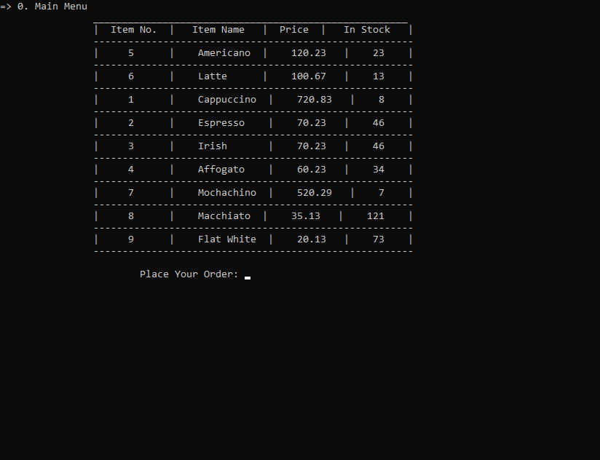

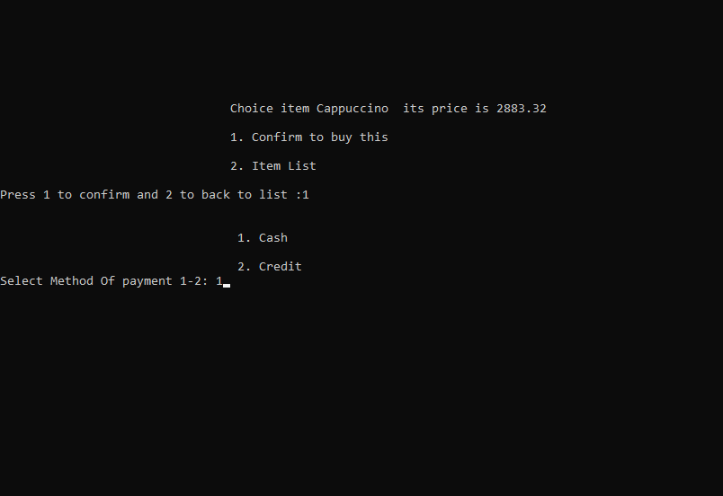

**REQUIREMENTS**

Hardware:

1. 512 MB of RAM or higher
2. 800 MHz processor or above
3. CD ROM
4. 20 MB of hard disk space

Software:

1. Operating System (Windows 98 or higher)
2. Turbo C++

**RESULT**

The project on the “Coffee Shop Management” is the success after the confirmation of its proper running and applications. With the introduction of this system in the market, the coffee business could certainly upgrade with no time. This can be the comprehensive and a very powerful tool for the proper management and promotion of this business.

This system is definitely a very convenient one. Here at the end, some of it important features can be listed out as follows:

1. Allow administrator to add, update and delete contents.

2. Users are able to order or cancel as their wish anytime very easily.

3. A well-organized viewing, order, and payment access to the customers.

4. Time, effort and money saving of the one holding the particular business.

**CONCLUSION**

As none of are 100% efficient or reliable, this management system could possibly hold some of the inevitable weaknesses but,it is the very applicable user friendly system to implement.

**REFERENCES**

Books:

* Programming in ANSIC by E. Balagurusamy
* Informatics study guide

Websites:

* http://gd.tuwien.ac.at/languages/Cprogramming-bbrown